Circulatory System – Notes
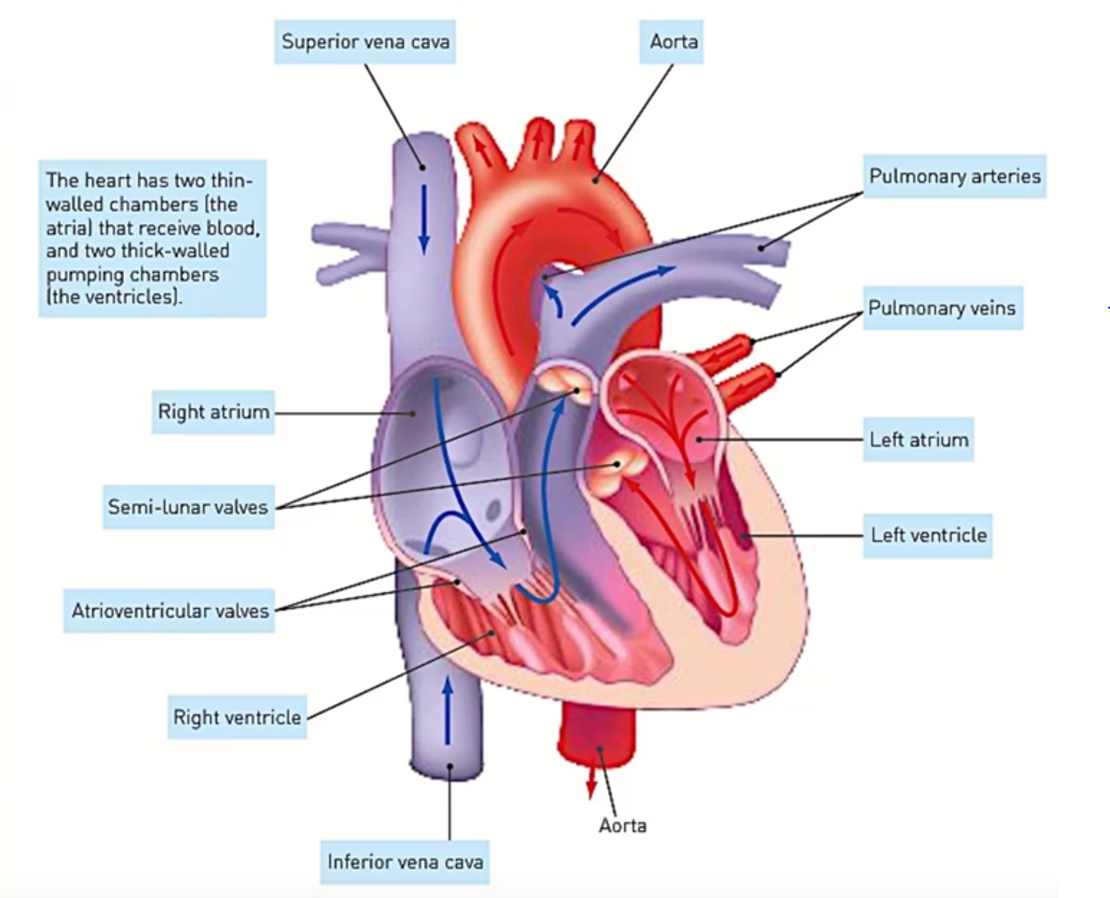
- Cardiac cycle: The sequence of events that occurs in one complete beat of the heart.

Structure of the heart:
- Superior vena cava – Returns deoxygenated blood from the head and arms.
- Right atrium – Pushes deoxygenated blood into the right ventricle.
- Inferior vena cava – Returns deoxygenated blood from the legs, abdomen, liver and kidneys.
- Tricuspid atrioventricular valve – Prevents backflow of blood from the right ventricle into the right atrium during ventricular systole.
- Chordae tendineae – Prevents the atrioventricular valves from inverting (turning inside out) during ventricular systole.
- Right ventricle – Pushes deoxygenated blood into the pulmonary artery towards the lungs.
- Left ventricle – Pushes oxygenated blood into the aorta towards all body tissue (except lung tissue).
- Papillary muscle – Contract to pull the chordae tendineae and open the atrioventricular valves during atrial systole.
- Semilunar valve – Prevents backflow of blood from an artery into the ventricle during ventricular diastole.
- Bicuspid atrioventricular valve – Prevents backflow of blood from the left ventricle into the left atrium during ventricular systole.
- Left atrium – Receives oxygenated blood from the lungs and pushes this blood into the left ventricle.
- Pulmonary vein – Carries oxygenated blood from the lungs to the left atrium.
- Aorta – Carries oxygenated blood from the left ventricle to the body tissues (except the lungs).
- Pulmonary artery – Carries deoxygenated blood from the right ventricle to the lungs.

There are 2 phases of the cardiac cycle:
- Pumping phase – Heart muscle contracts – called systole.
- Filling phase – Heart muscle relaxes – called diastole.

- For a short time, both atria and ventricles are in diastole – the atria fill with blood and the ventricles also receive blood as the valves between them are open.

- The atrioventricular valves regulate the blood flow between the atria and the ventricles.
- In the cardiac cycle, you always start off with diastole. When both the atria and the ventricles are in diastole, blood flows in from the vena cava into the right atrium and from the pulmonary veins into the left atrium.
- Since the atrioventricular valves are currently open, the blood flows directly from the atria into the ventricles.
- Once blood has filled both the atria and the ventricles, atrial systole occurs.

- Atrial systole – Contraction of the atria – follows and forces the remaining blood into the ventricles.
- Atria now relax and refill while the ventricles contract in ventricular systole.
- Ventricular systole forces blood into the arteries – to the lungs via the pulmonary artery or to the rest of the body via the aorta.
- Although the left and right sides of the heart are 2 pumps, they operate together – both atria contract simultaneously and so do both ventricles.

- The rate of blood flow depends on how fast the heart is beating and how much blood the heart pumps with each beat.
- Heart rate: The number of heart beats per minute (bpm).
- Stroke volume: The volume of blood forced from a ventricle with each contraction (mL).
- Cardiac output: The amount of blood leaving one of the ventricles every minute.

Cardiac output (mL/minute) = Stroke volume (mL) x heart rate (bpm).

Functions of blood:
- Transport of oxygen and nutrients to all cells.
- Transport of carbon dioxide and other waste products away from cells.
- Transport of chemical messengers – hormones.
- Maintaining the pH of body fluids.
- Distributing heat and maintaining body temperature.
- Maintaining water content and ion concentration of body fluids.
- Protection against disease-causing micro-organisms.
- Clotting when vessels are damaged, preventing blood loss.
(Nothing Without Harry Potter Tampers With Immoral Democratic Characteristics)

Blood as a transport medium:
Blood is made up of:
- Liquid part – plasma (water, proteins and salts).
- Non-liquid part – Cells and cell fragments – formed elements.

- Plasma makes up ~55% of blood volume. Formed elements make up the other 45%.
- Formed elements that are suspended in blood plasma include:
- Red blood cells (erythrocytes).
- White blood cells (leukocytes).
- Platelets (thrombocytes).
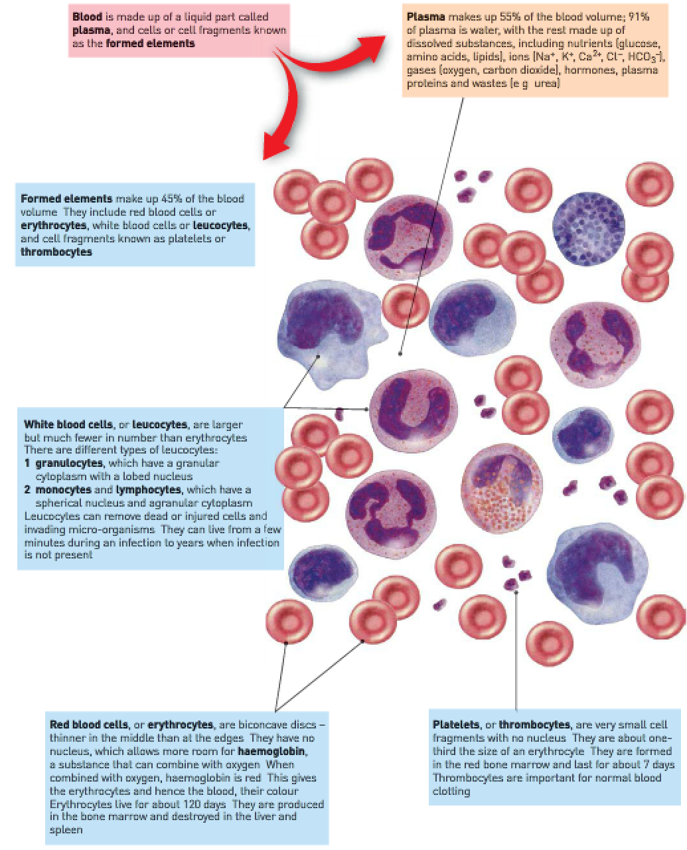
Types of leukocytes:
- Basophil.
- Eosinophil.
- Neutrophil.
- Monocyte.
- Lymphocyte.
Erythrocytes:
- Erythrocytes work as a transport of oxygen.
- Oxygen isn’t very soluble in water – only ~3% of oxygen is dissolved in plasma.
- The other 97% is carried in combination with haemoglobin molecules that are found only in erythrocytes.
- Haemoglobin is able to combine with oxygen to form oxyhaemoglobin
- Oxyhaemoglobin can easily break apart to release oxygen, hence the combination of oxygen and haemoglobin is said to be “loose”.

Haemoglobin Haemoglobin Oxygen

- The presence of haemoglobin in erythrocytes increases its oxygen-carrying capacity by 60-70 times.
- Oxygen combines with haemoglobin in the lungs where the oxygen concentration is relatively high. Oxygen diffuses into the blood through the alveoli.
- Oxyhaemoglobin breaks down to haemoglobin and oxygen in situations where the oxygen concentration is relatively low – tissue fluid around cells have relatively low oxygen concentration.
- While flowing through capillaries between cells, erythrocytes give up their oxygen which diffuses into tissue fluid and then into cells.

Erythrocytes work as a transport of carbon dioxide:
Carbon dioxide is carried in several ways:
- ~7-8% is dissolved in plasma and carried in solution.
- ~22% combines with the globin part of the haemoglobin molecule to form carbaminohaemoglobin.
- ~70% is carried in plasma as bicarbonate ions (HCO₃⁻).

- As blood flows through capillaries between body cells, carbon dioxide diffuses from the blood into the plasma due to the higher concentration of carbon dioxide in the tissue fluid and the lower concentration of carbon dioxide in the plasma.
- Some carbon dioxide dissolves in plasma and some combines with haemoglobin. Most reacts with water to form carbonic acid (H₂CO₃). Carbonic acid then dissociates into hydrogen ions and bicarbonate ions.

Carbonic acid Hydrogen ions Bicarbonate ions
- Alveoli are surrounded by a dense network of capillaries.
- Carbon dioxide dissolved in the plasma in the capillaries diffuses out of the blood into the air in alveoli.
- Carbaminohaemoglobin breaks down and the carbon dioxide released diffuses into the alveoli.
- Hydrogen ions and bicarbonate ions recombine to form carbonic acid in the plasma which then breaks under enzyme action into water and carbon dioxide. This carbon dioxide diffuses into the alveoli.
Oxygen: | Carbon dioxide:
3% dissolved in plasma. | 8% dissolved in plasma.
97% transported as oxyhaemoglobin. | 22% as carbaminohaemoglobin.
 | 70% as bicarbonate ions.

Transport of nutrients and waste:
- Nutrients: Essential elements and molecules obtained from food.
- Inorganic nutrients are transported as ions.
- Organic nutrients (such as glucose, vitamins, amino acids, fatty acids and glycerol) are dissolved in plasma.
- Metabolic wastes: Substances produced by the cells that can’t be used and would be harmful if allowed to accumulate.
- The most important organic wastes that are transported in solution in the blood plasma are:
- Urea.
- Creatinine.
- Uric acid.
Blood vessels:
- Blood is pumped into blood vessels.
- Blood vessels carry the blood to the cells of the body or the lungs and then bring it back to the heart.
- Movement of blood is referred to as the circulation.
- Blood vessels join together to form the channels through which blood flows through.

- Arteries – Carry blood away from the heart.
- Capillaries – Carry blood between the cells.
- Veins – Carry blood back to the heart.

Blood flow in arteries:
- Arteries carry blood away from the heart – the walls contain smooth muscle and elastic fibres.
- When the ventricles contract and push blood into the arteries, the walls of the arteries stretch to accommodate the extra blood – this produces the pulse.
- When the ventricles relax, the elastic artery walls recoil – this keeps blood moving and maintains pressure.

- Arterial muscles can contract to reduce the diameter of arteries, reducing blood flow to an organ (vasoconstriction).
- Arterial muscles may relax and increase the diameter of arties, increasing blood flow to an organ (vasodilation).
- This allows for the changing needs of the body.

- Large arteries that receive blood pumped by the ventricles divide into smaller arteries known as arterioles which supply blood to the capillaries. Arterioles have smooth muscle in their walls.
- The contraction and expansion of this muscle is very important in regulating blood flow through the capillaries (via vasoconstriction and vasodilation).

Blood flow in veins:
- Veins don’t have muscular walls – they’re unable to change their diameter in the same way that arteries do.
- Venules: Tiny veins that carry blood away from capillaries. Venules don’t have muscle in their walls that can change their diameter.

Blood flow in capillaries:
- Capillaries: Microscopic blood vessels that form a network, carrying blood close to every cell.
- Enables cells to get their requirements from blood and to pass their waste into blood.
- The structure of capillaries suits their function – capillary walls consist of only one layer of cells, allowing substances to pass easily (and rapidly) between blood and surrounding cells.

Movement of blood back to the heart:
- Blood in the veins is under low pressure. The blood is unable to move back to the heart solely from heart contractions alone. The loss of pressure is too great.
- Skeletal muscle movements push against the sides of flexible large veins, causing blood to push back against one-way valves in veins. The valves close, preventing backflow and forcing the blood to move towards the heart.
- This process is called venous return.
Arteries: | Veins:
Carry blood away from the heart. | Carry blood towards the heart.
Have a blood pressure that increases as the ventricles contract and decreases as the ventricles relax. | Has a constant, relatively low blood pressure.
Have thick, muscular, elastic walls. | Have thin, relatively inelastic walls with little muscle.
Have no valves. | Often have valves.

Blood clotting:
- Arterial smooth muscles constrict to reduce blood flow.
- Rough surfaces of the damaged blood vessels allow thrombocytes to stick.
- Allows other thrombocytes to also stick, creating a plug.
- Thrombocytes release vasoconstrictor chemicals which enhance and prolong constriction.
- More than sufficient to stop bleeding in small capillary injuries.

More serious injuries require a blood clot (coagulation of blood):
- Requires the formation of clotting factors in the plasma.
- Chemical reactions create insoluble protein called fibrin.
- Fibrin threads form a mesh that traps erythrocytes, thrombocytes and plasma.
- Fibrin threads hold the clot in position.
- Clot retraction – The threads contract, pulling the edges of the blood vessels together and squeezing out fluid called serum.
- The clot dries, forming a scab.

Blood types:
Antigen: Any substance that stimulates an immune response.
Antibody: A protein produced by lymphocytes that’s specific to an antigen.

There are 2 types of antigens:
- Self-antigen: Things from inside the body that stimulate an immune response.
- Foreign antigen: Things from outside the body that stimulate an immune response.

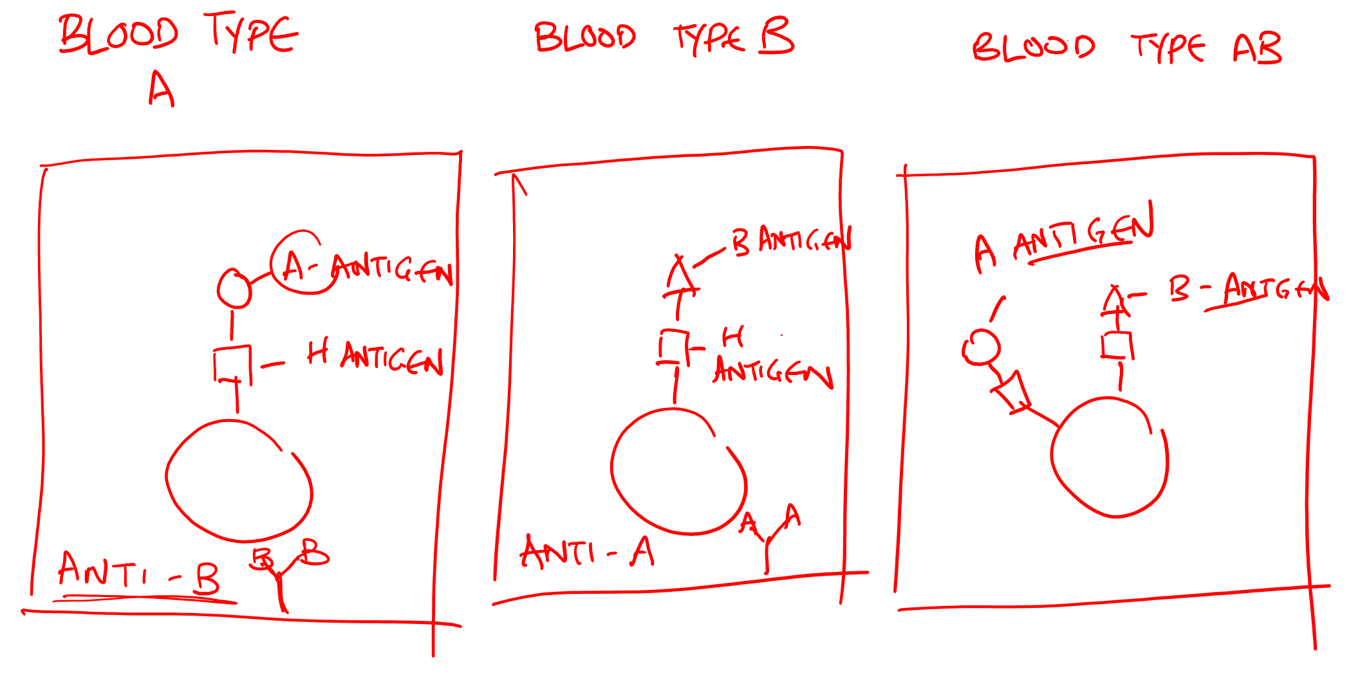
Blood type A has an A-antigen. Because this is a self-antigen, it isn’t good for the body to produce an antibody to the A-antigen. Through natural processes, the body will produce an antibody to the B-antigen, which is called anti-B.

Person A of a certain blood type can't give their blood to Person B who's blood has an antibody that will react with the antigen present in the blood of Person A, but Person A can give their blood to a person who's blood doesn't have an antibody that will react with the antigen in the blood of Person A, hence making some blood types compatible and some not.

Blood type A/B/AB/O simply refer to the antigen present in the plasma of a person's blood, and +/- simply refer to the presence/absence of the D-antigen (and hence also the absence/presence of anti-D).

O A, B and AB.
A A and AB.
B B and AB.
AB A, B, AB and O.

RhD antigen present Positive (+).
RhD antigen absent Negative (-).

A person of blood type positive has the D-antigen and hence doesn’t have anti-D. A person of blood type negative doesn’t have the D-antigen and hence has anti-D. This means that the 2 can’t mix since the D-antigen would react with the anti-D, causing a transfusion reaction.

Blood group: | Antigens on erythrocytes: | Antibodies in thrombocytes:
A | Antigen A | Anti-B
B | Antigen B | Anti-B
AB | Antigen A + antigen B | Neither anti-A nor anti-B
O | Neither antigen A nor antigen B | Both anti-A and anti-B

Transfusions:
- The mixing of blood types that are incompatible can cause the euthrocytes to clump together or agglutinate.
- If the receiver’s blood contains, or is able to make, antibodies against the antigens on the donor’s erythrocytes, the foreign cells will clump together and disintegrate.
- It’s essential that the blood group of the receiver and donor be the same.
- The ABO blood group of the donor is always matched to that of the receiver when transfusions are given.
- Rh blood groups are also matched for transfusion purposes.

Types of transfusions:
Whole blood: Blood as it’s taken from the donor but with a chemical added to preventing clotting.
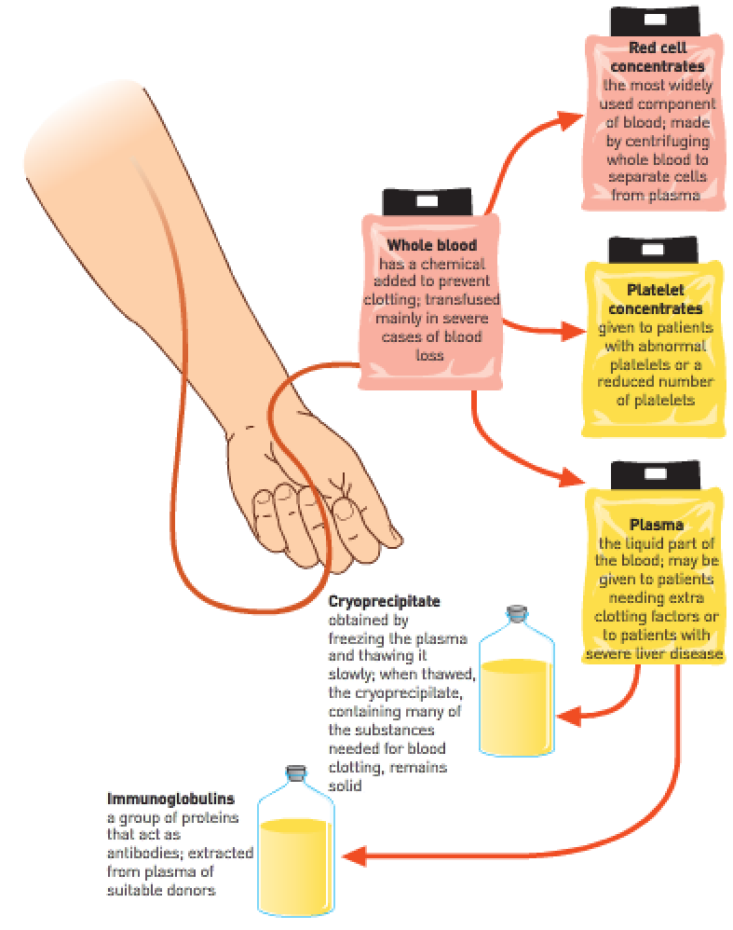
- Red cell concentrates – Produced by spinning blood at very high speed in a centrifuge; the heavier cells sink to the bottom, leaving the lighter plasma on top; concentrate may or may not have platelets and leukocytes removed; transfusions of erythrocyte concentrates are used for patients suffering from heart disease or severe anaemia.
- Plasma – Given to patients requiring extra clotting factors for control of severe bleeding, or to patients with liver disease.
- Platelet concentrates – Given to patients who have abnormal platelets or a reduced number of platelets.
- Cryoprecipitate – Obtained by freezing the plasma and thawing it slowly; when the plasma is thawed, the cryoprecipitate remains solid; it contains many substances necessary for blood clotting; may be used to treat some forms of haemophilia, but most often for sever bleeding.
- Immunoglobulins – A group of proteins that act as antibodies; extracted from the blood and used for patients who are deficient in antibodies; particular immunoglobulins from certain donors are used to treat patients who have no immunity to a particular disease e.g., tetanus immunoglobulin many be used to treat tetanus.
- Autologous transfusion – When the patient’s own blood is used; blood is collected from the patient prior to an operation that may require a transfusion; eliminates the risk of transmission of disease and possible side effects of the usual transfusions.

WACE Study Guide:
Blood pressure in the arteries should be highest during ventricular systole.
Blood pressure in the arteries should be highest during ventricular diastole.

Pulmonary circulation – Pulmonary arteries and pulmonary veins.
Systemic circulation – Aorta, carotid arteries, mesenteric arteries, renal arteries, inferior and superior venae cavae.

Oxygen – Required to release energy from glucose in aerobic respiration.
Glucose – Provides the chemical energy which is released in respiration.
Minerals – Used in metabolic processes to synthesise substances needed by cells.
These are carried to the body cells in the blood plasma of the circulatory system. They leave the capillaries and diffuse into the tissue fluid and then into the cells.
Humans and other complex multicellular organisms require a circulatory system because larger organisms can’t obtain oxygen and nutrients or dispose of wastes simply by diffusion to the external environment. This would be too slow.

The blood’s circulatory system connects all organs of the body because no living cell is more than 130μm from a capillary. Thus, the circulatory system permeates throughout the body and joins all the organs in this way.

Inflammation is a defense response to cell damage caused by foreign substances or microorganisms. The site of injury/invasion becomes red, indicating vasodilation has occurred. Temperature rises as more heat is produced. White blood cells leave the circulation at the injury site to engulf foreign particles and remove it.

Arteries usually carry oxygenated blood and veins usually carry deoxygenated blood.
The pulmonary artery is the only artery that carries deoxygenated blood.
The pulmonary vein is the only vein that carries oxygenated blood.
The hepatic portal vein is unique in that it carries food (glucose, amino acids, etc) that has been absorbed from the small intestine.

Components of blood:
- Carbaminohaemoglobin – A compound formed when carbon dioxide combines with haemoglobin in the red blood cells.
- Deoxygenated blood – Blood which has lost most of its oxygen to the body tissue.
- Fibrinogen – A soluble protein which occurs in blood plasma. When converted to fibrin, by thrombin, it plays a major role in forming a blood clot.
- Haemorrhage – The loss of blood from a damaged blood vesse.
- Plasma – The fluid part of the blood.
- Platelet (thrombocyte) – A small volume of cytoplasm bounded by a cell membrane, but lacking a nucleus.

Blood is classified as connective tissue because it consists of living cells surrounded by a non-living matrix of fluid, the plasma.

